Shealtiel Mulder

Baoqing Xie



**Game Instructionsthth**



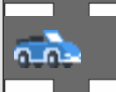

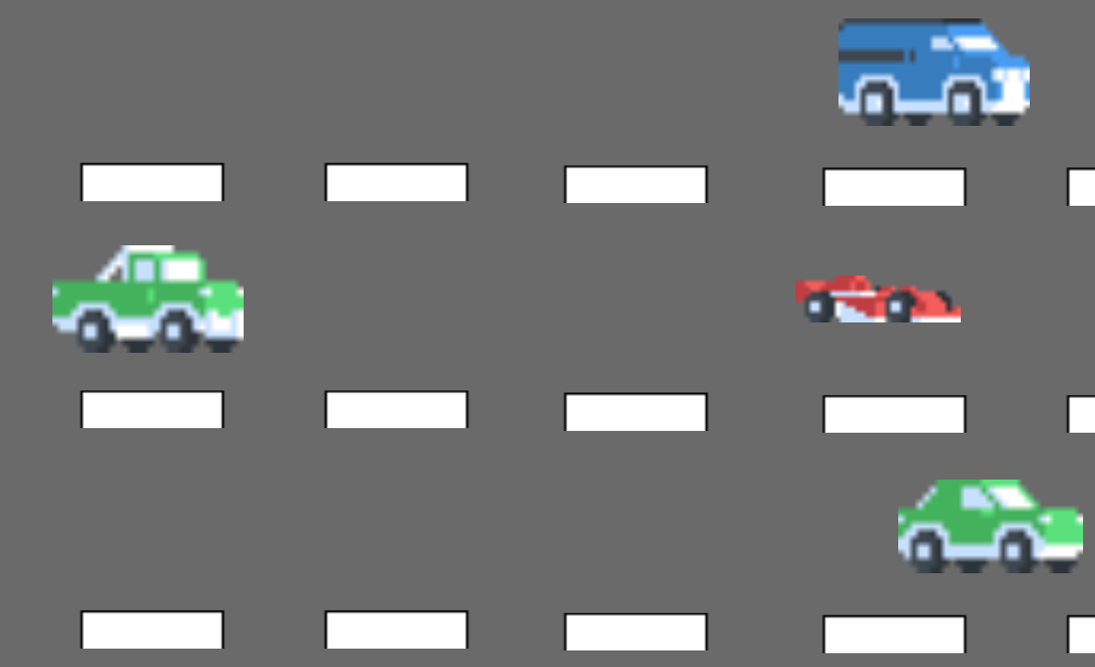



Font for Main Menu, Game Over screen, and this document:

<https://textcraft.net/>

Pixel pack for vehicles and the road:

<https://www.kenney.nl/assets>

Main Menu music, and in-game music:

<http://freemusicarchive.org/genre/Chiptune/>

Crash sound and sound for a successful match:

<http://soundbible.com/royalty-free-sounds-1.html>

Bao’s Contributions:

Random Car Spawn

Road Design

Road Movement Effect

Car Destroy on exiting Boundary

Individual Car Speed

Shealtiel’s Contributions:

Random Player Car movement

Theme and Concept

Explosion Effect

Crash Sound

Menu and Game Over music & screen design